Straight line mix-up

Here are nine function cards:
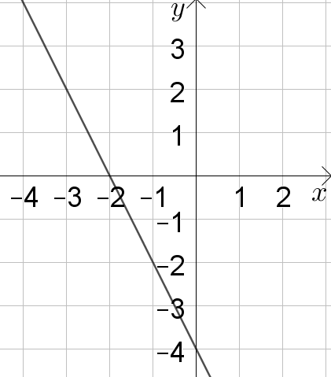 | 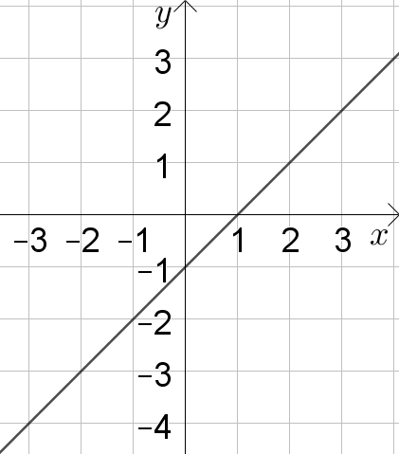 | 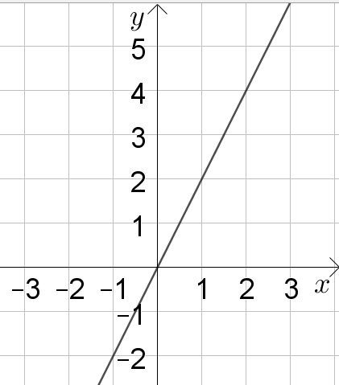
$$y=4-2x$$ | $$y=3x-4$$ | $$y=x$$
  $$x$$ | -1 | 0 | 1 | 2
  $$y$$ | 2 | 0 | -2 | -4
  $$x$$ | -1 | 0 | 1 | 2
  $$y$$ | 0 | 3 | 6 | 9
  $$x$$ | -1 | 0 | 1 | 2
  $$y$$ | 3 | 4 | 5 | 6
You may wish to sketch the graphs, work out the equations, and work out a table of values for each card.
Here are six property cards:
The gradient is positive | The gradient is negative | The y intercept is negative | The line passes through (0,0) | The line is parallel to $y=x+2$ | The y intercept is positive

Can you find a way to arrange the property cards and the function cards in a grid, so that each function satisfies the property at the top of its column and at the left of its row?
For example, in the grid below, $y=3x-4$has a positive gradient and a negative y intercept.
 |  | The gradient is positive
The y intercept is negative |  | $$y=3x-4$$

Is there more than one way to arrange the cards?
Straight line mix-up
Teachers’ Resources
Why do this problem?
In this problem, students are invited to characterise the properties of a group of straight line graphs, and classify them according to their gradients and intercepts. To sort the cards, students will need to reason about which combinations are possible, and to switch between graphical, algebraic and tabular representations of functions.
Possible approach
Each pair of students will need a set of cards.
Draw a table on the board, like the one below:
The y intercept
is positive
Parallel to y = 0 |  | *
Choose two properties like the ones in the table (one of which appears in the problem), and invite students to suggest functions/graphs which could go in the cell marked *.
Then set them the challenge of arranging the six property cards in the column and row headings so that they can find a home for all nine function cards in the grid.
While students work in pairs, listen out for useful strategies and insights that can be shared with the whole class. For example, some students might choose to sketch graphs so they can visualise the ones expressed as tables or equations. Others might write all nine as equations and use what they know about $y=mx+c$ to classify them. Students might also observe that some pairs of properties are mutually exclusive.
Once they have successfully arranged all fifteen cards, finish off the lesson by discussing why there is essentially only one possible solution.
Key questions
Which cards could go in more than one place?
Which cards can only go in one place?
Possible support
Students could start with a smaller grid, using just four of the properties to start off with.
Possible extension
Invite students to choose their own functions and properties to create an arrangement which they can then cut up and swap with a partner to reassemble.
Straight line mix-up
Resource Sheet

The y intercept is negative | The line passes through $(0,0)$ | The y intercept is positive
The gradient is  positive | The line is parallel to the line $y=x+2$ | The gradient is negative
$$y=4-2x$$ | $$y=3x-4$$ | $$y=x$$
  $$x$$ | -1 | 0 | 1 | 2
  $$y$$ | 2 | 0 | -2 | -4
  $$x$$ | -1 | 0 | 1 | 2
  $$y$$ | 0 | 3 | 6 | 9
  $$x$$ | -1 | 0 | 1 | 2
  $$y$$ | 3 | 4 | 5 | 6

